Instructions:
This assessment consists of five separate sections.
Each section is scored in four areas, for a total of 20 questions.
Your individual section scores as well as your overall quiz score is explained at the end of the assessment.

Section One
Competitive Capabilities
SCORE | QUESTION
________ | - Does your company have an established and profitable domestic market for your product or service?  - No (0)  - Somewhat (2)  - Yes (5)
________ | - Is your company financially stable with at least three years of profitability as well as sustained positive cash flow?  - No (0)  - Somewhat (2)  - Yes (5)
________ | - Do your product lines offer significant competitive advantages over products of the best companies in the world in terms of prices, features and/or benefits?  - No (0)  - Somewhat (2)  - Yes (5)
________ | - Have professional budgeting and financial management processes been in place in your company for at least several years?  - No (0)  - Somewhat (2)  - Yes (5)

* Each question has a maximum score of 5 points, for a maximum score of 20 points per section.

Section One Score

Section Two
Motivation for Going International
SCORE | QUESTION
________ | - Is exporting part of your company's long-term expansion strategy and not solely a mitigation strategy for excess inventory or seasonal market fluctuations?  - No (0)  - Somewhat (2)  - Yes (5)
________ | - Does your company have a formal documented export plan with defined goals and strategies?  - No (0)  - Somewhat (2)  - Yes (5)
________ | - Is your company committed to providing the same level of service given to your domestic customers?  - No (0)  - Somewhat (2)  - Yes (5)
________ | - Have you conducted any market research to identify or confirm high potential foreign markets for your products or services?  - No (0)  - Somewhat (2)  - Yes (5)

Section Two Score

Section Three
Commitment of Owners and Top Management
SCORE | QUESTION
________ | - Are your company’s owners and top management absolutely committed to developing export markets and are willing and able to dedicate staff, time and resources to the process?  - No (0)  - Somewhat (2)  - Yes (5)
________ | - Has your company’s management identified a dedicated person whose primary responsibility will be the export operations?  - No (0)  - Somewhat (2)  - Yes (5)
________ | - Is your company’s management willing to wait long enough (possibly two to three years) to achieve acceptable export results on their initial foreign market investment?  - No (0)  - Somewhat (2)  - Yes (5)
________ | - Do the members of your current management team have exporting or international marketing experience?  - No (0)  - Somewhat (2)  - Yes (5)

Section Three Score

Section Four
Product Readiness for Foreign Markets
SCORE | QUESTION
________ | - Does your company have spare production capacity along with a reliable supply chain that can meet large orders from foreign buyers?  - No (0)  - Somewhat (2)  - Yes (5)
________ | - Is your product compliant with U.S. and target market trade and safety regulations (such as ITAR compliance and CE marking)?  - No (0)  - Somewhat (2)  - Yes (5)
________ | - Does your company have adequate knowledge and capability to customize your product and its packaging in order to meet foreign market demands and cultural preferences?  - No (0)  - Somewhat (2)  - Yes (5)
________ | - Are you capable of providing any special training, on-the-ground technical support, or other after-sale service or support your product or service may require in the target market?  - No (0)  - Somewhat (2)  - Yes (5)

Section Four Score

Section Five
Skill, Knowledge and Resources
SCORE | QUESTION
________ | - Does your company have knowledge in shipping its product overseas, such as identifying and selecting international freight forwarders and freight costing?  - No (0)  - Somewhat (2)  - Yes (5)
________ | - Does your company have knowledge of international payment methods (such as securing letters of credit) and other concerns that come with international transactions (such as impact of currency fluctuations)?  - No (0)  - Somewhat (2)  - Yes (5)
________ | - Does your company have knowledge of foreign competitors, their products, their marketing strategies and pricing practices?  - No (0)  - Somewhat (2)  - Yes (5)
________ | - Does your company have a visible presence on the Internet (through a professional website, international trade directories, etc.)?  - No (0)  - Somewhat (2)  - Yes (5)

Section Five Score

Individual Section Scoring
Calculate your individual sections and overall score.
Step One
Copy your scores for the section to the table below to see your readiness level (Low-Medium-High) for each section.
Step Two
Combine your section scores together to see your total score and check your overall readiness level using the table below.
Dimension | TOTAL | Low | Medium | High
Competitive Capabilities |  | 0-6 | 7-13 | 14-20
Motivation for Going International |  | 0-6 | 7-13 | 14-20
Commitment of Owners and Top  Management |  | 0-6 | 7-13 | 14-20
Product Readiness for Foreign Markets |  | 0-6 | 7-13 | 14-20
Skill, Knowledge and Resources |  | 0-6 | 7-13 | 14-20
All Sections Combined

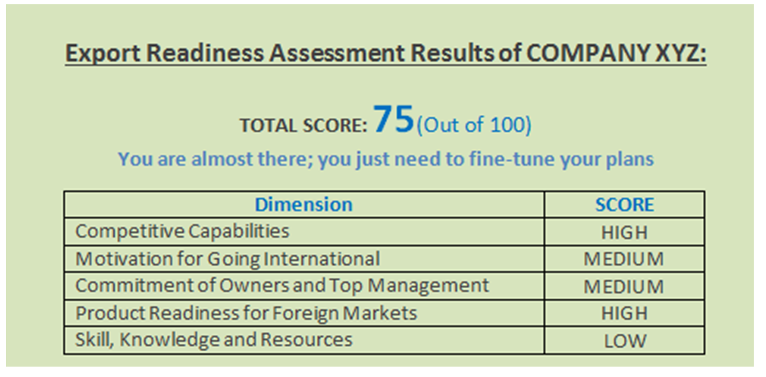
Your sample score card should look something similar to this:

Overall Readiness Scoring
Match your total score below to discover your export readiness.

Total Score
0-20 | You are on the right track, but you need additional guidance.
21-39 | A good beginning, but you still have work to do.
40-65 | You are on the way to becoming a successful exporter.
66-84 | You are almost there; you just need to fine-tune your plans.
85-100 | You are ready to be successful in your exporting venture.
Total Scoring Legend

RESOURCE:
- Step-by-Step Guide to Exporting

NEXT STEP:
Wherever your Export Readiness Quiz score, the Kansas Department of Commerce’s International Division can help you become a successful exporter.
Contact Rosie Nichols to schedule a meeting to determine what programs and services can help you.
 | Rosie Nichols  International Development Representative  Rosie.Nichols@ks.gov  (785) 289-3345  Kansas Department of Commerce  1000 S.W. Jackson Street, Suite 100  Topeka, KS 66612-1354  www.KansasCommerce.gov  (785) 296-3841

